**NAAN MUDHALVAN – GUIDED PROJECT** 

**DOCUMENTATION**

|  |  |
| --- | --- |
| DATE | 31 OCTOBER 2023 |
| TEAM MEMBERS WITH NM ID | 1. HEMAH P   NM ID: 26C8ACB2D68B750B23 948062A9FDBD7B   1. JAYASHREE S   NM ID: ED018CE4032A071BB3C45143295B8FD7   1. KARAN R   NM ID: 6DD5B3DC8A86F23A1814299AF568A66A   1. KUMARAGHAN S M   NM ID: D8C6A6C4026C2CFA0294CEA4BB99ED6C |
| PROJECT NAME | DIGITAL ASSET MANAGEMENT USING BLOCKCHAIN TECHNOLOGY |
| COLLEGE NAME | ALAGAPPA COLLEGE OF TECHNOLOGY, ANNA UNIVERSITY |

The proposed solution architecture for the Digital Asset Management system integrates various technologies seamlessly within Visual Studio Code, offering a comprehensive development environment. Leveraging Hyperledger Fabric for a permissioned blockchain, smart contracts are developed using Solidity in Visual Studio Code, with Remix IDE providing a web-based interface and node.js connector for testing. The system incorporates IPFS for decentralized storage, with file explorer integration in Visual Studio Code facilitating efficient asset management. User authentication is secured through blockchain IDs and MetaMask integration. The user interface is designed using HTML, CSS, and JavaScript within Visual Studio Code, ensuring compatibility with the MetaMask Chrome extension. Security measures include end-to-end encryption and MetaMask for secure transactions. Scalability is addressed through sharding strategies and caching mechanisms integrated into Visual Studio Code. Real-time monitoring and an analytics dashboard enhance visibility into blockchain activity and system performance. This architecture thus creates a unified, secure, and user-friendly ecosystem for developing and deploying a robust Digital Asset Management system.

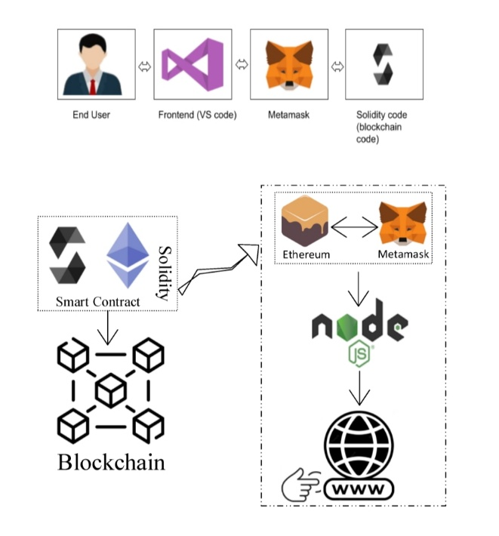

Prerequisite:

1. download node.js : Node.js
2. download vs code: Li4nk
3. download metamask : https://metamask.io/

Steps to complete the project

Step 1:-

1. Open the Zip file and download the zip file.

2. Extract all zip files

Step 2 :

1.Open vs code in the left top select open folder. Select extracted file and open .

2. Select the projectname.sol file and copy the code.

3. Open the remix ide platform and create a new file by giving the name of projectname.sol and paste the code which you copied from vs code.

4. Click on solidity compiler and click compile the projectname.sol

5. Deploy the smart contract by clicking on the deploy and run transaction.

6. select injected provider - MetaMask. In environment

7. Click on deploy. Automatically MetaMask will open and give confirmation. You will get a pop up click on ok.

8. In the Deployed contract you can see one address copy the address.

9. Open vs code and search for the connector.js. In contract.js you can paste the address at the bottom of the code. In export const address.

10. Save the code.

Step 3: open file explorer

1. Open the extracted file and click on the folder.

2. Open src, and search for utiles.

3 . You can see the frontend files. Select all the things at the top in the search bar by clicking alt+ A. Search for cmd

4. Open cmd enter commands

npm install

npm bootstrap

npm start

5. It will install all the packages and after completing it will open {LOCALHOST IP ADDRESS} copy the address and open it to chrome so you can see the frontend of your project.